# Video Aesthetics

## Filming Locations

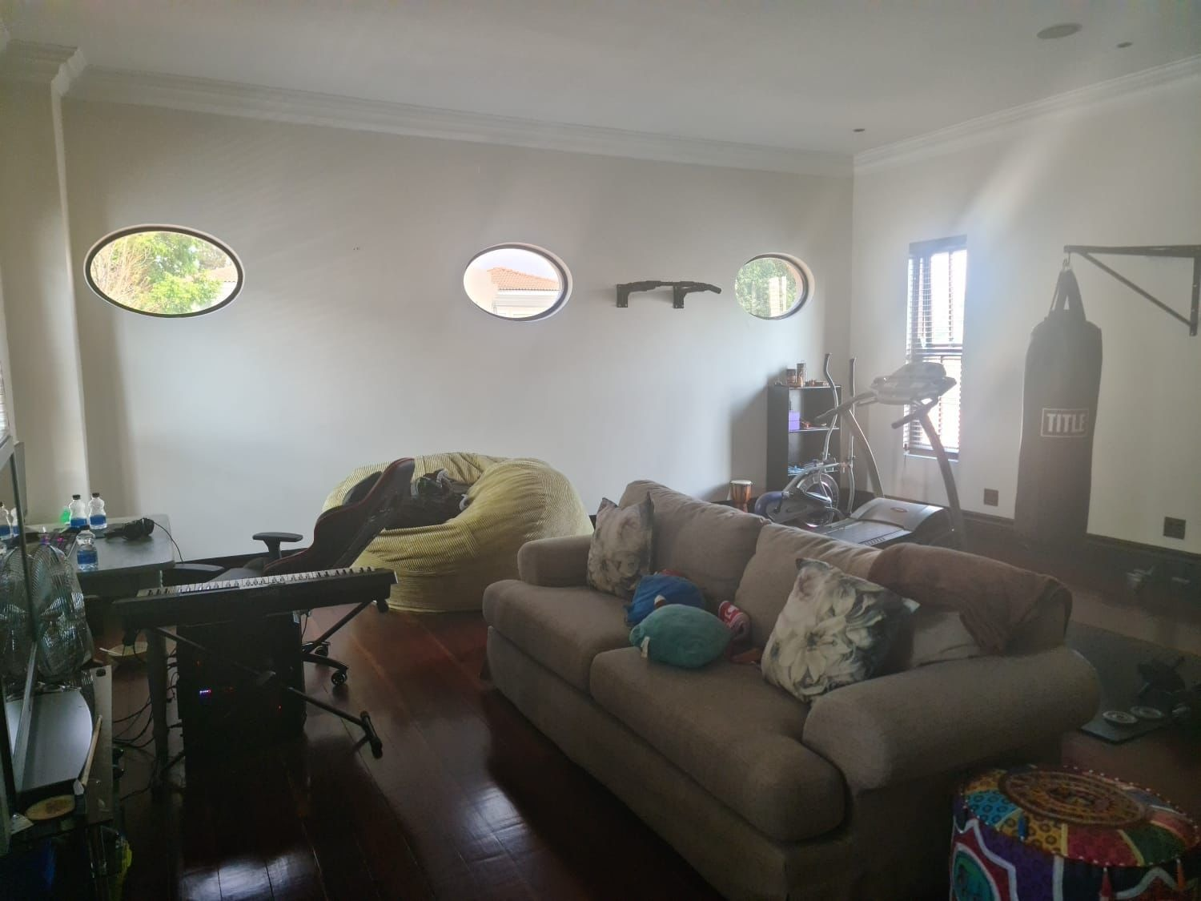

Study Space

Room will be empty with just a desk and a few items to make the space feel less comfortable and more empty.

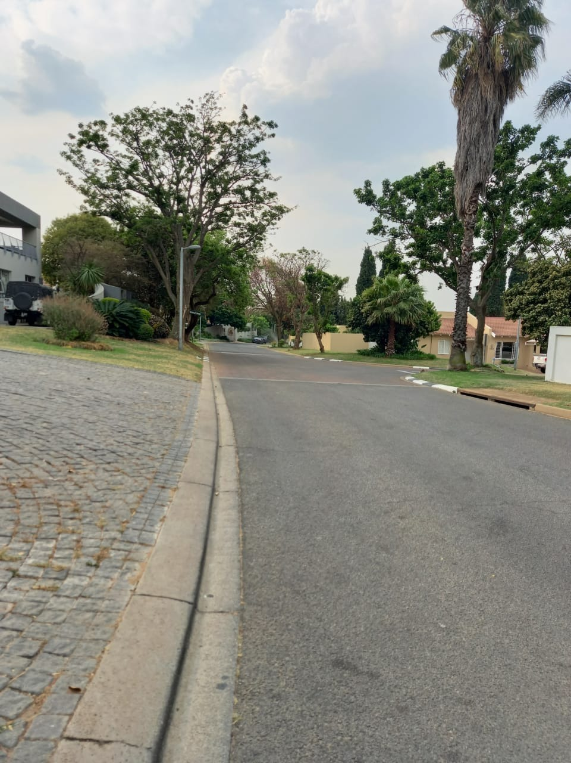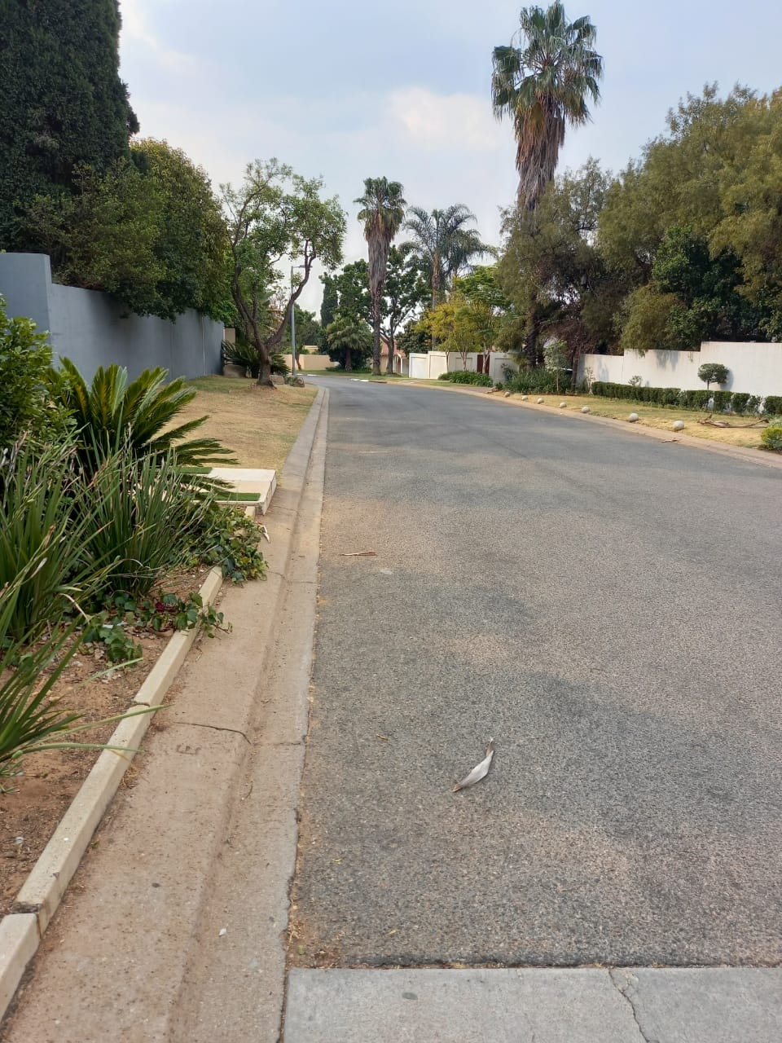

Area where Tom will be walking home

We chose this room for the study space because it has ample space to create this lonely atmosphere. The area where Tom will be walking has great spots for the hidden figure to be standing in and has enough space to film multiple angles and shots if needed on the day.

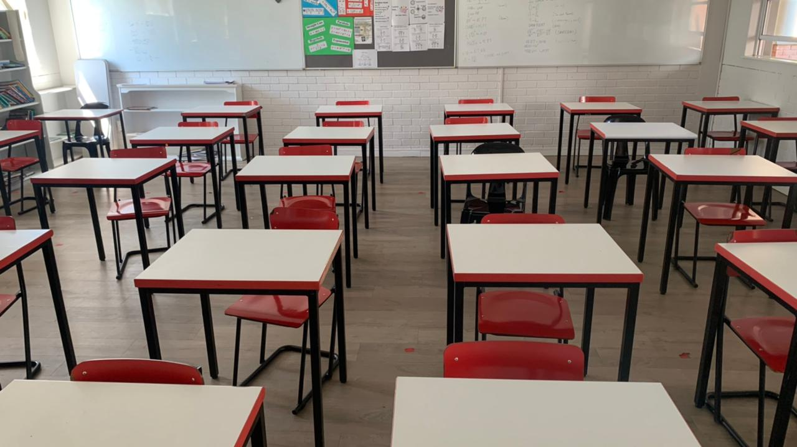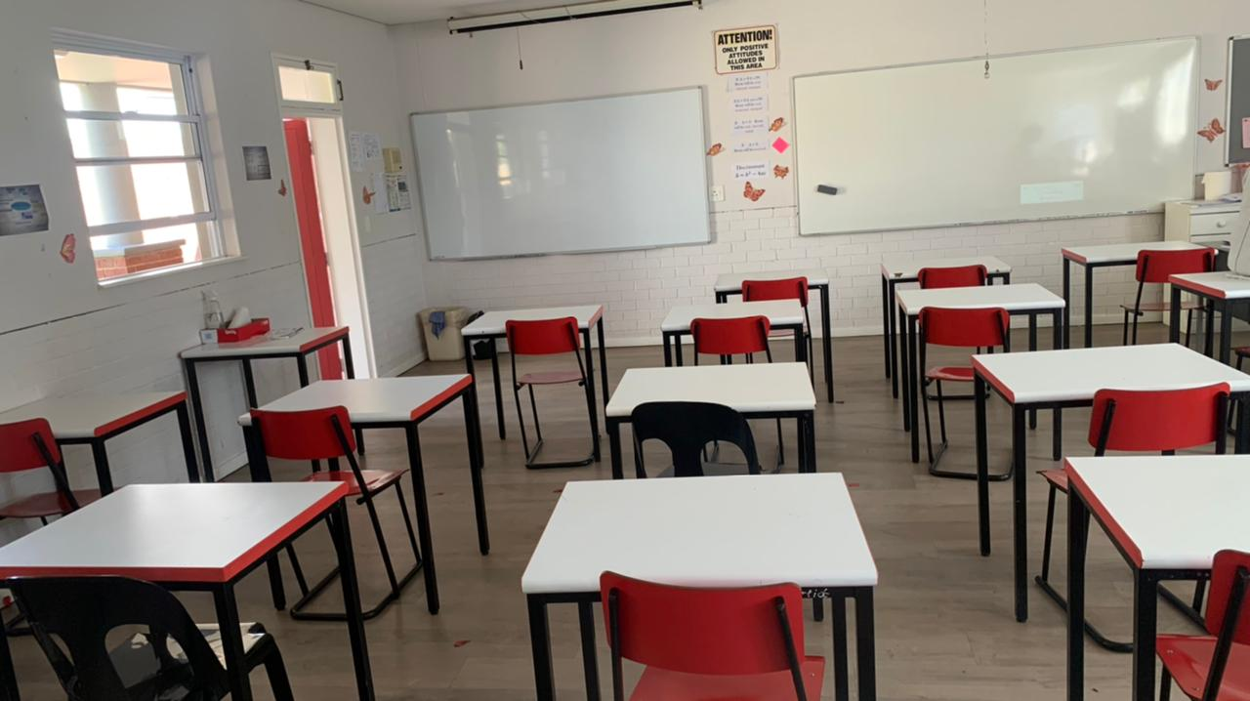

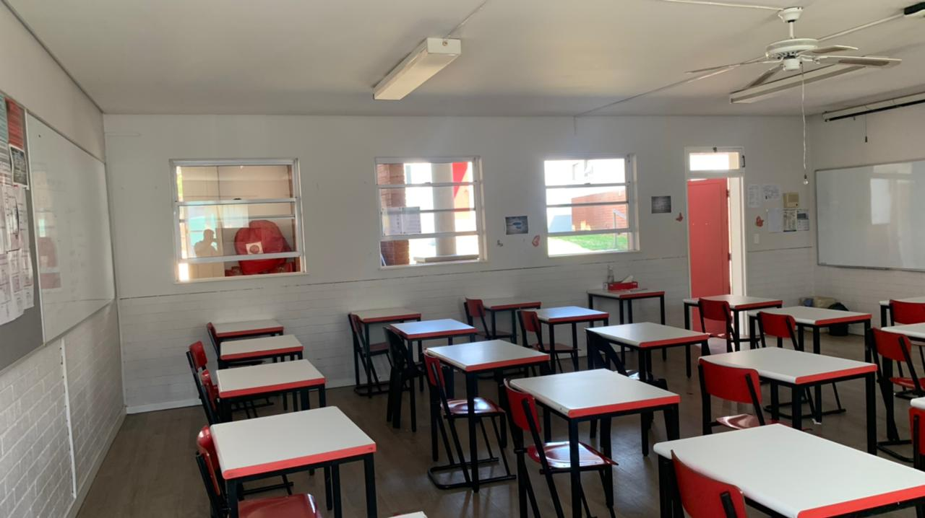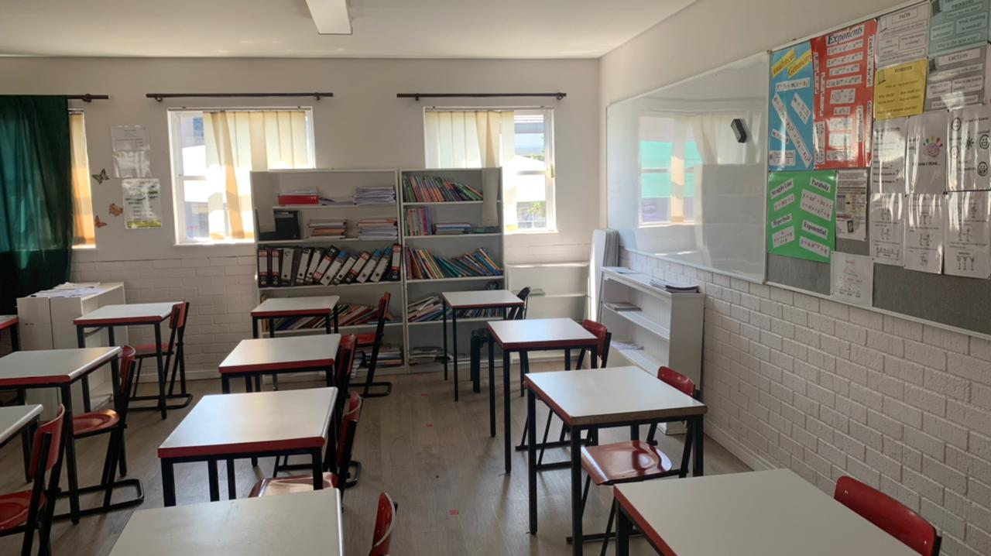

Classroom we will be using for the school scene

With the classroom, we just have to work with what he were given because the pandemic has restricted us to being only able to use this specific classroom. We would have liked a classroom that had more curtains so we can simulate darker light for our scenes but we will have to work around our situation and use our bleach bypass colour grading to help with our lighting problems.

## Props

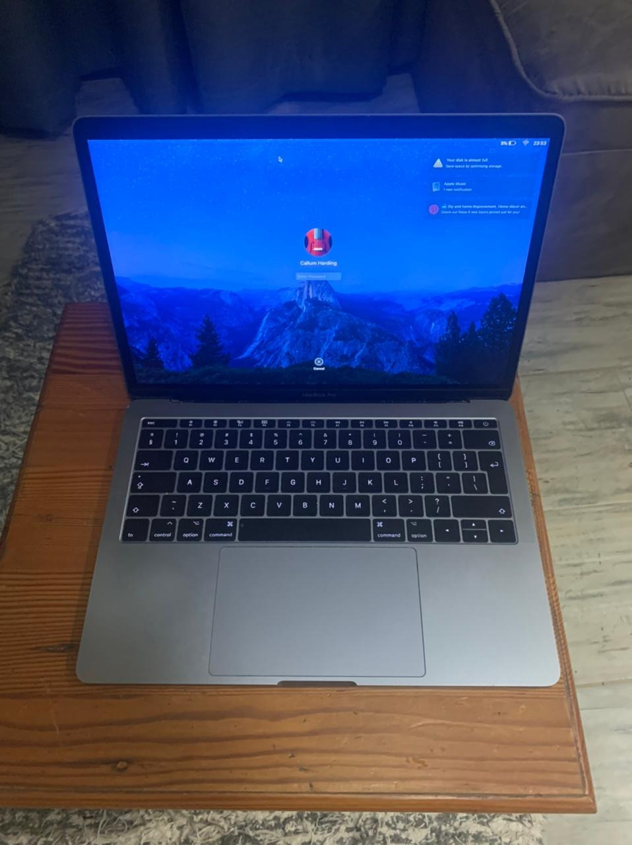

Laptop

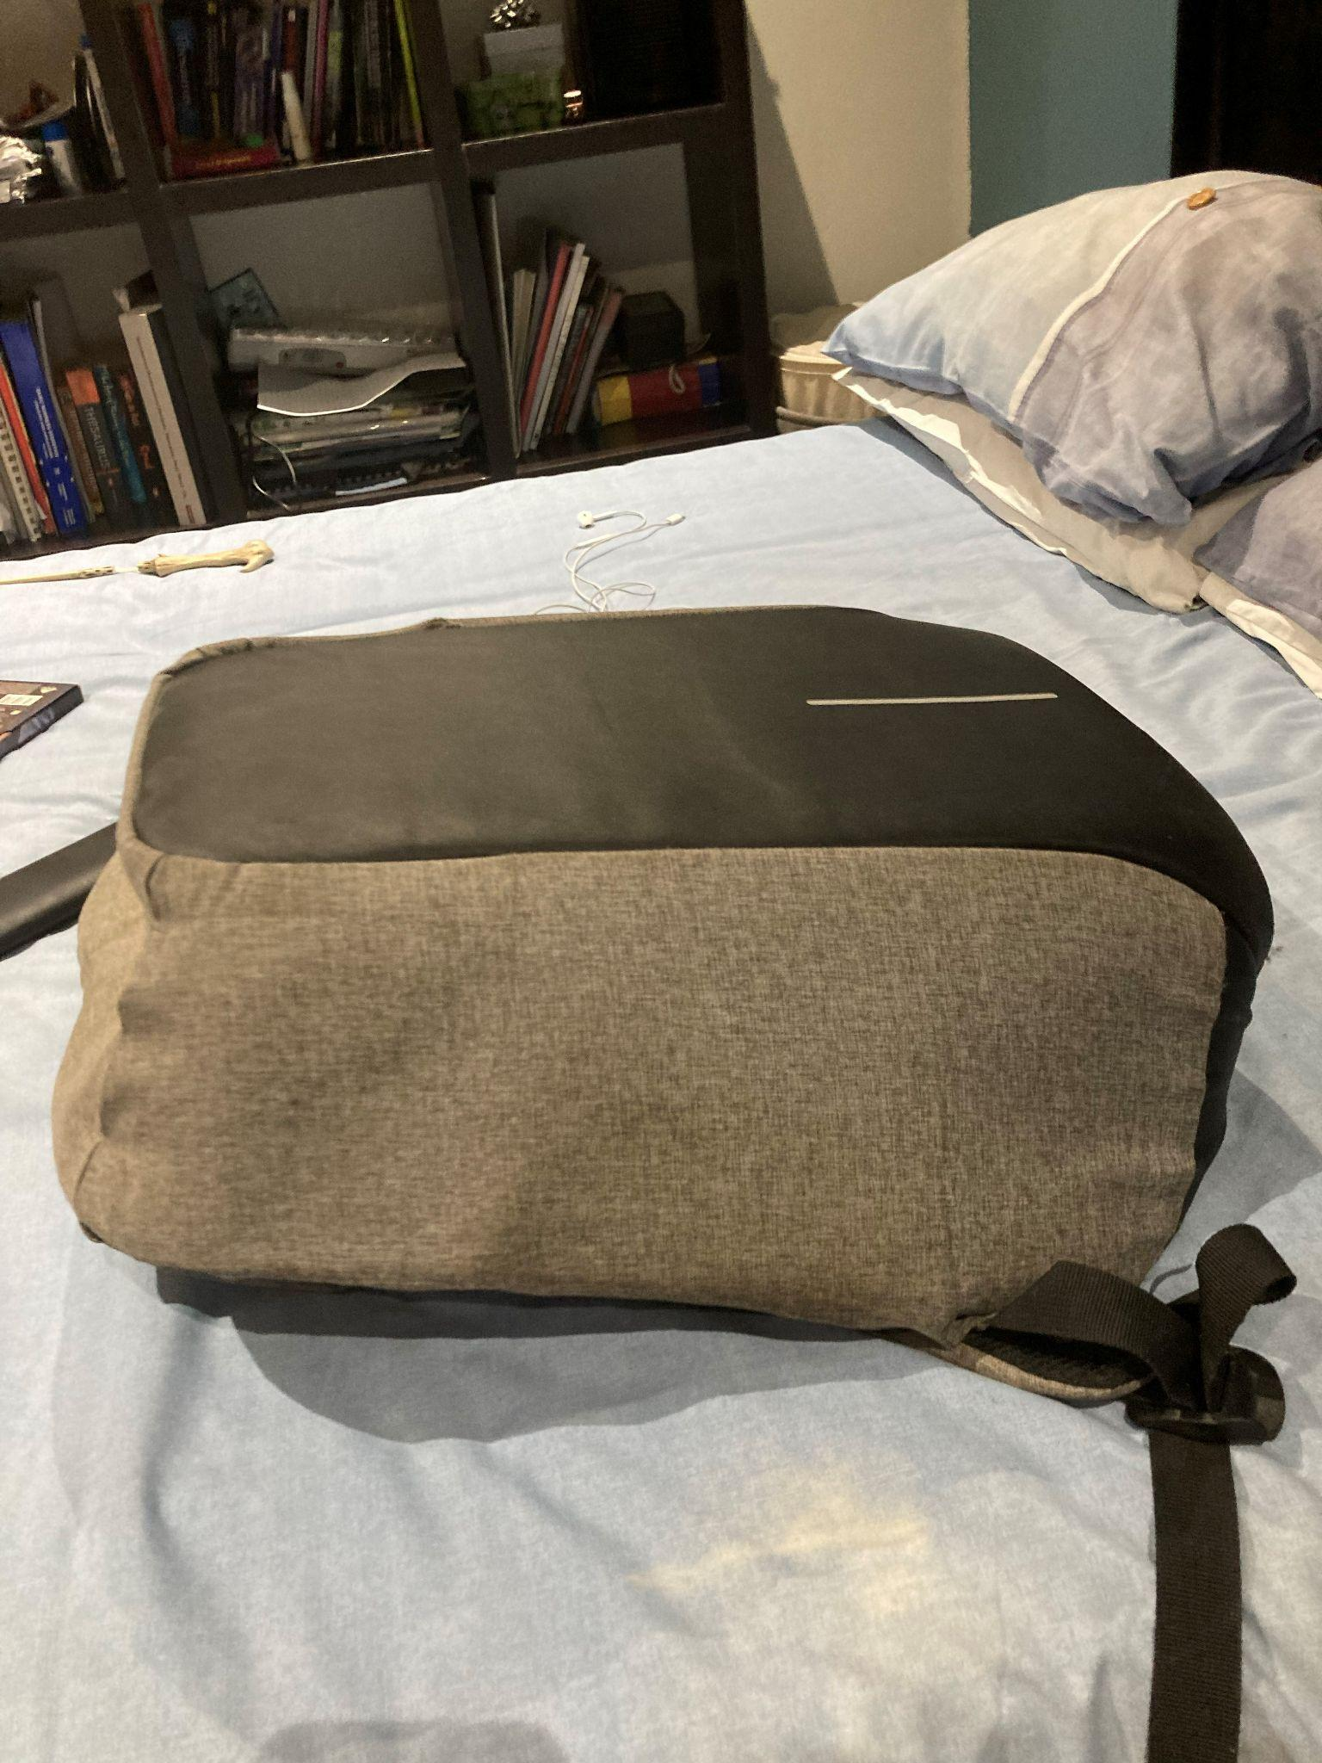

School bag

## Fonts

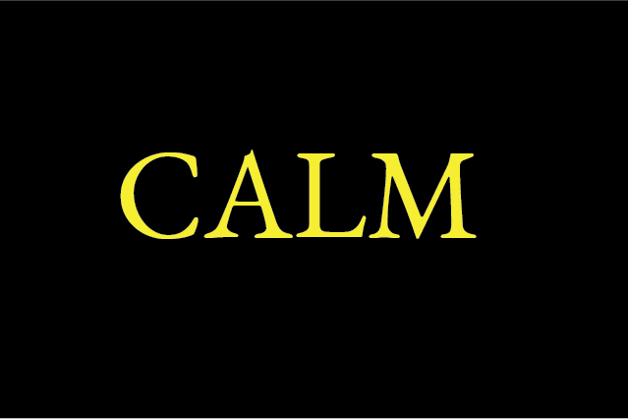

We chose EB Garamond as our font because the kerning is very tight and compact just like most of the close up shots that will appear in the film to show the stress and anxiety within the character. We chose yellow because it is a striking colour and stands out which is in complete contrast to our character who is lonely.

## Two Important Scenes

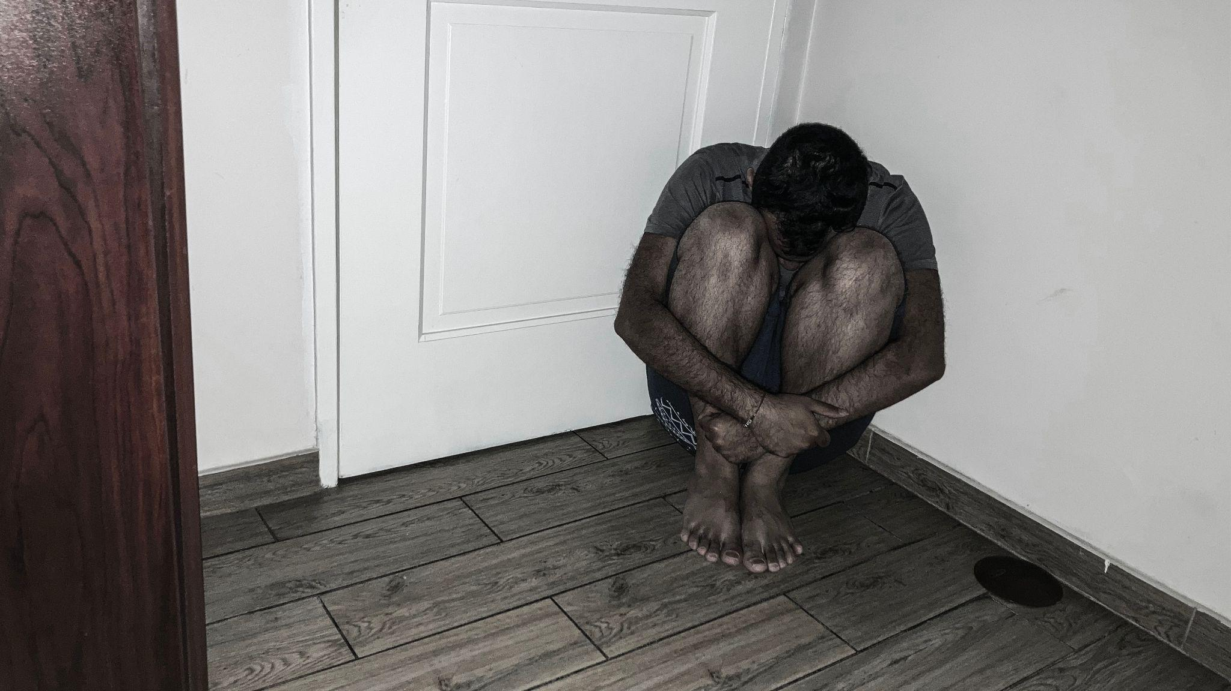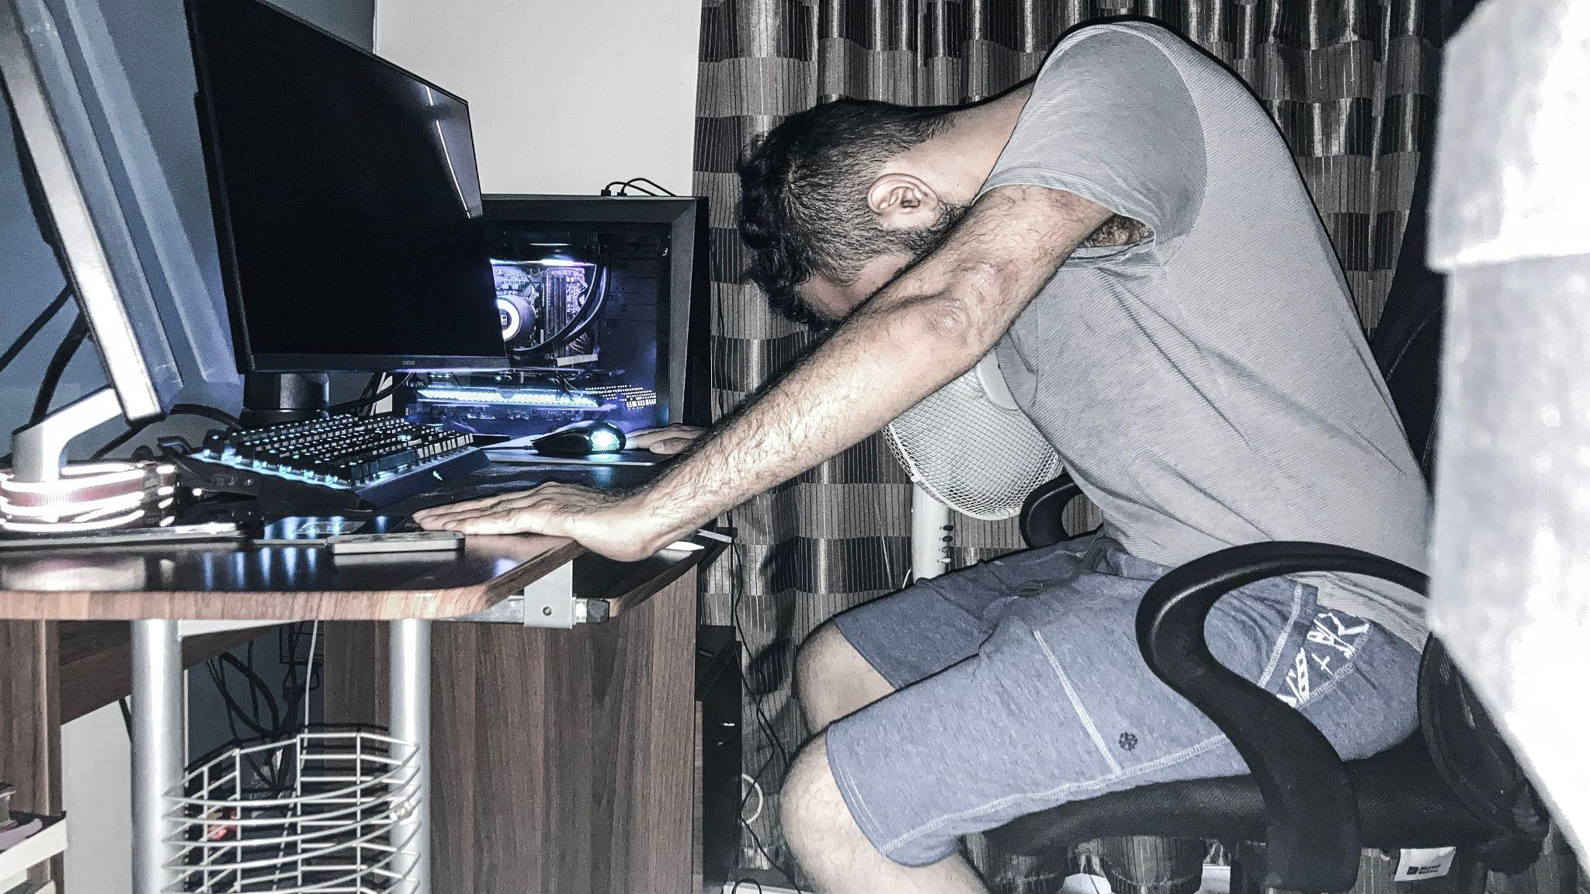

We chose a bleach bypass colour effect for our film because it has a grim look to it and relates well to the feeling the main character will be going through. When Tom is being haunted by the hidden figure and gets very stressed the film colour will almost look monochromatic while when he is not stressing it will still have the bleach bypass effect with desaturated colours to keep the bleach bypass effect.

# Audio Aesthetics

## Ambient Noise

### Low Rumble

For use during intense scenes. Makes the listener feel stressed and aware, drawing attention to the scene occurring.

### School background noise

This audio contents background talking and general background noise for use in the school scenes when things are happening around the characters. The voices and ambient sounds are purposely louder and overpowering to emphasise the anxiety and stress the main character is feeling as a result of his surroundings.

## Sound Effects

The following sound effects have been created:

* Door Knock 3
  + Sound used when Tom’s father knocks on the door. This is a harsh knocking sound used to wake Tom up.
* Door Opening
  + The sound of a door opening used after knocking (may be replaced with actual audio when filming).
* Door Closing
  + The sound of Tom’s father closing the door behind him (may also be replaced with actual audio when filming)
* Heavy Breathing
  + The breathing sound heard by Tom in the corner of his room coming from the poorly lit figure. This is a deep breathing sound which will be recreated after filming to fit in with the visuals.
* Loud Chewing
  + The sound of chewing gum that Tom will hear several times during the film. This sound will be re-recorded and adjusted to match the visuals after filming.
* School Bell
  + The sound of a regular school bell for use in the school scene.

## Music

All music used is original and has been composed specifically for this film. These songs are samples of the music that will be used and may be adjusted for use in the film as well as different music composed in the same style as the samples provided.

### Background Music

This is a sample of the style of background music to be used during the film. This track, composed in the key of C minor, makes use of several sounds and instruments. A constant bass note panned from left to right is used to make the listener feel uneasy. The high notes are made using a synth pad, again in the key of C minor, also creating an uncomfortable feeling. The use of reverb and an atmospheric sampler make the notes fade into one another and reverberate all around. Throughout the track, there are also slight rumbles and effects to add an additional layer of suspense as well as a sharp crash and high pitched string ensemble that will be adjusted and used in various scenes where a sudden “shock” is necessary. This sample will be adjusted and added to in order to fit the various scenes once filming is complete.

### Credits Music

This song, also composed in the key of C minor, is a simple track that will be used when the credits roll. It makes use of a section of low stringed basses playing a basic set of notes to establish the key. Violas are then added playing a higher melody followed by a cinema string ensemble playing a very high pitched set of notes creating a feeling of suspense. The synth pad used in the background music is also present, linking this end credit song with the music throughout the film. An interrupted cadence is used at the end of the credits music in order to leave the viewer with an uneasy feeling and a question of what is to come by sounding incomplete.